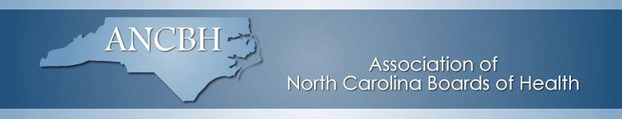The Association of North Carolina Board of Health is now accepting nominations for the following three awards.

Carl Durham Award
Eligible: Institutional, Individual, Associate or Emeritus Member of ANCBH
Nominee:
- has made significant contributions to public health
- is an effective advocate for public health at the local, regional, and/or state levels

Outstanding Board of Health Award
Eligible: ANCBH Institutional Member
Nominee:
- The board’s leadership in public health accomplishments must be clearly evident.
- The accomplishment must either have documented results or be currently producing intended results.
- The activity may be accomplished through the health department, other agencies, or groups.

Robert Ed Strother Partnership Award
Eligible: Individual
Nominee:
- Established and/or fostered a public-private partnership, which has improved public health for the community.

Nominations are due by August 31, 2021

Two nomination forms are available. One fillable form can be completed on the computer, saved and emailed. This form can be printed also. The other form is a traditional paper form which can be completed and mailed. It can be scanned and emailed also. Nominations should be sent to:

Dr. Calvert Jeffers at cjeffers@triad.rr.com and

Edna Hensey at ehenseyANCBH@gmail.com

Revised 8/5/21

